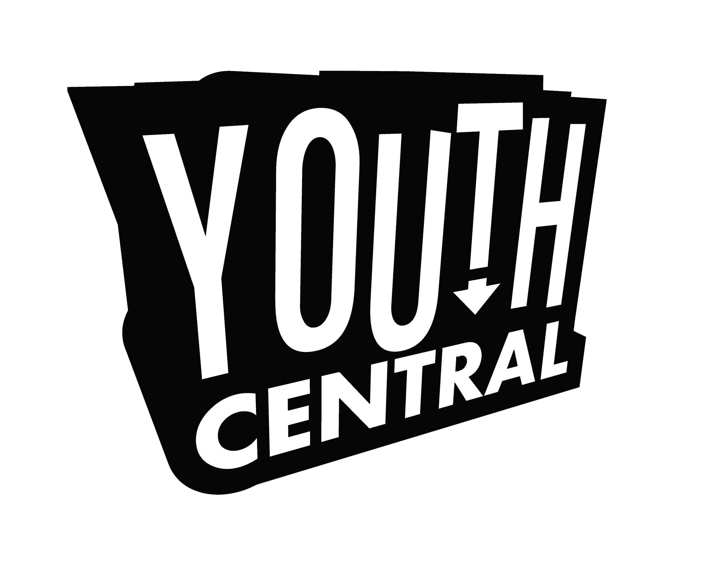  Youth Central Youth Volunteer Intake for Calgary Youth Justice Society | For internal use  Date:  Processed: ☐Y☐N
This form is PRIVATE AND CONFIDENTIAL and for Youth Central’s use only. We will not share any of this information.

Referred Youth’s Information

Legal First and Last Name: Birth Date:
Day Month Year

Street Address: City: Postal Code:

Home Phone: Cell phone:
Email address:
Gender: ☐ Male ☐ Female ☐ Transgender ☐ Non binary/non-conforming ☐ Prefer Not to Answer

Additional Information
Name of Referring Person: Youth Justice Committee:

How many volunteer hours or projects are required to be completed?

Date that hours or projects need to be completed by:

☐ This youth requires someone other than a parent/legal guardian to sign the Youth Central Parent/Guardian Consent & Release Form. In this case, the Calgary Youth Justice Society has designated an alternate person who is authorized to sign this form.
Authorized Name: ___________________________________________________

